* Re: IIS –configure a webpath

Alternative 1

* 1. Under “Default Web Site” , right click “Add virtual directory”
  2. Fill “Alias” and “Physical Path” and continue
  3. 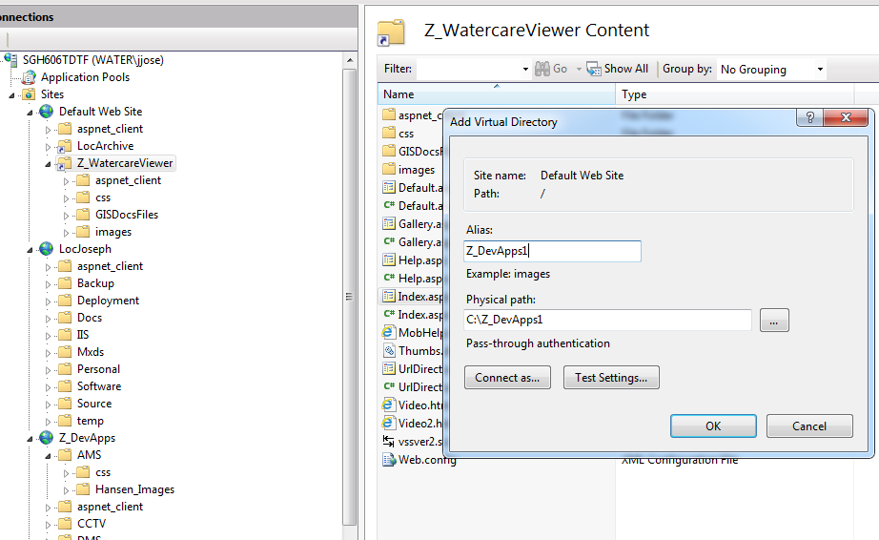

 Alternative 2

1. Under “Sites” , right click “Add Web Site”
2. Enter blank location for “Physical Path”. This is a caching area

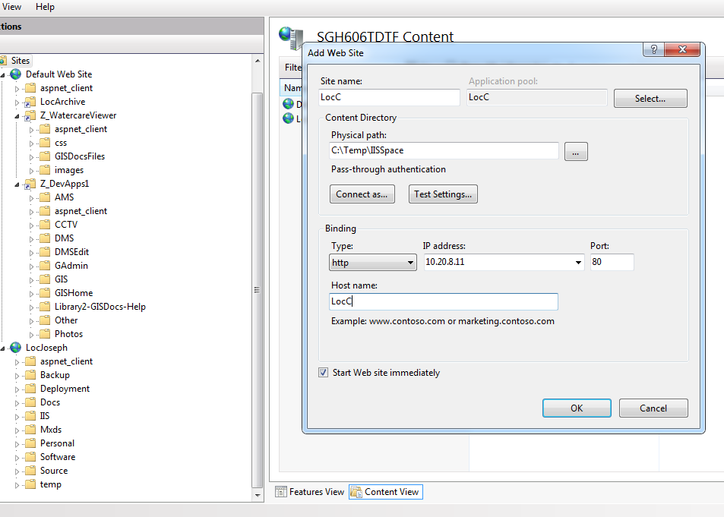

1. Follow steps under “Alternative 1”